**Tests for the member dimension and the fact flight**

1. **Test of the member dimension:** We made a test that demonstrates that new, deleted and changed rows in the table member are correctly type-2 updated in the members dimension.

First, we create a **new member** with initials “dwhg” and name “data” into the “taMember”:

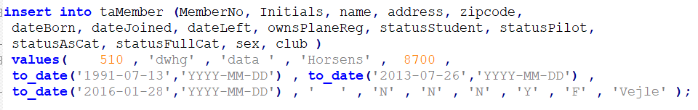

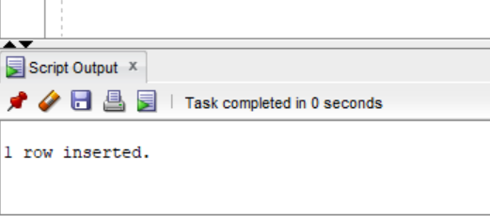

Then, we run the ETL for d_member:

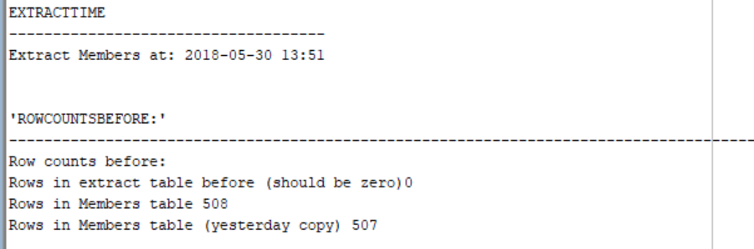

And here we can see that the dimension member was correctly updated with the new member

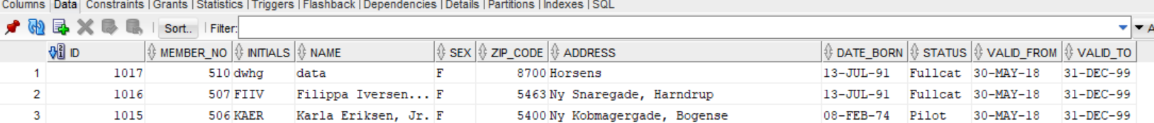

In the second test, we **change** the name of the member that we created before:

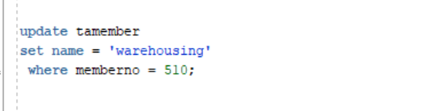

We run the ETL again:

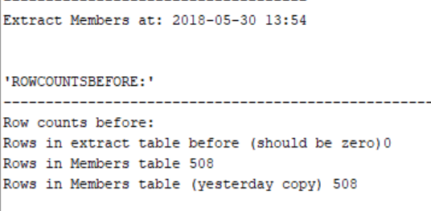

And we can see that the table dimension members was correctly updated:



For the third test, we **deleted** the member that we created before:

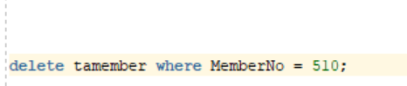

We run the ETL:

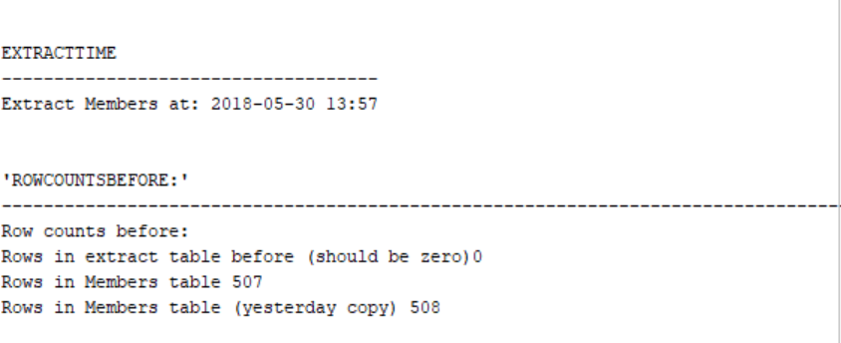

Here we can see that the table dimension members correctly updated, because it set the valid_to date for the member deleted to today’s date:

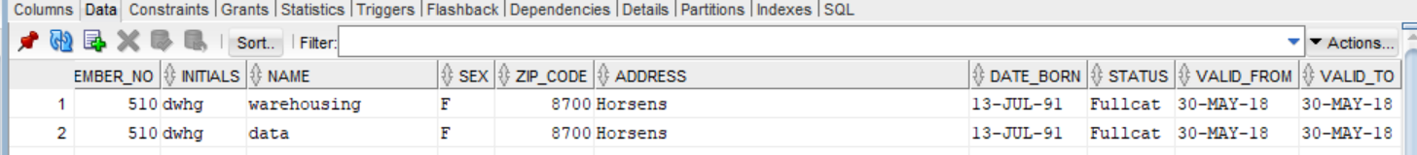

1. **Test of the fact table** that demonstrate the correct insertion of facts for a single-pilot and a two-pilot flight:

First we **inserted 2 new flights**, one with **one pilot**, and the second one with **2 pilots** in the taFlightsSG70.

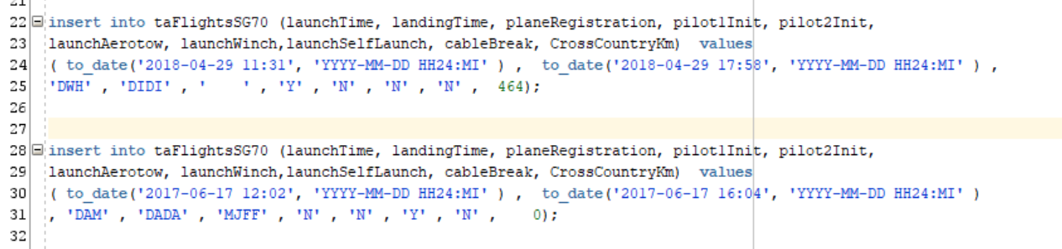

We didn’t have an extract report for flight to show the result of the rows extracted, but after running the ETL this is the F_FLIGHT dimension, where you can see that the flights were inserted (we have made fake information in the launch_method_id, plane_id and club_id because we didn’t populate those tables. The rows inserted are the ones with group_id “15067” and “15068”.

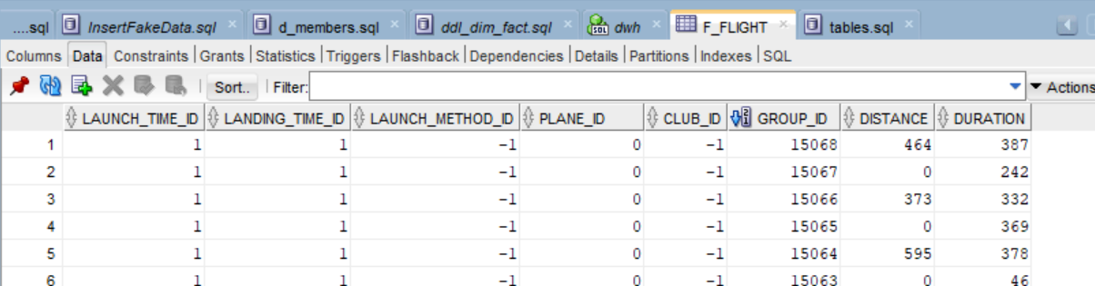

And here, we can see the correct insertion of the information into the bridge table, the rows inserted are the ones with group_id “15067” and “15068”. The group id is the same for the flight with two pilots and their respective weight is 0.5.

